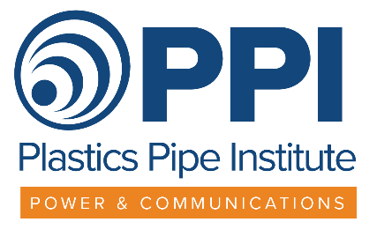
NEWS RELEASE
NY News Contact: Steve Cooper
516/623-7615
PPI News Contact: David Fink 469/499-1046

SAFE HDPE CONDUIT
PULL STRENGTH
DOCUMENT NOW AVAILABLE

IRVING, Texas – September 14, 2021 - The Plastics Pipe Institute, Inc. (PPI) Power & Communications Division has released a new Technical Note to assist conduit installers in calculating safe pulling loads in order to avoid damaging high-density polyethylene (HDPE) conduit. TN-63 is available for free at https://plasticpipe.org/pdf/tn-63-2021.pdf PPI is the major North American trade association representing the plastic pipe industry.
“When pulling HDPE conduit into place, an increasing axial tensile load will be exerted on the conduit,” explained Patrick Vibien, P, Eng., director of engineering for the PCD. “If the Safe Pull Strength is exceeded during installation the conduit may permanently deform at some location along its length. This necking down may create an obstruction within the conduit such that when the cable is later pulled into place, it is be blocked from passing through this section. Knowing the Safe Pull Strength will protect the conduit during installation and the investment in the installation.”
PPI TN-63 Safe Pull Strength Calculations for Conduit: including Derating Factors provides not only the equations used to calculated the Safe Pull Strength (SPS) for HDPE conduit but easy-reference tables of pre-calculated SPS values for typical industry HDPE conduit wall diameters and thickness types. Guidance is also provided on how to derate the Safe Pull Strength for elevated temperature installation and time-under-tension considerations.
-more-
-2-
Installers can quickly look-up the Safe Pull Strength for the conduit they are using from the tables, derating it for actual ambient temperature conditions and the time under tension, for use with an in-line tensiometer or in selecting the breakaway link with the correct rating. The SPS values already include the appropriate safety factor.
TN-63 is applicable to any pulled into place installation, including open trench and Horizontal Directional Drilling (HDD) methods. Tables of SPS values are provided for industry standard DR and Schedule wall types, up to six inches in diameter. An explanation the behavior of conduit under load is provided and guidance on installation considerations is included.
Published on PPI’s website TN-63, is one of several PPI documents related to the design and installation of HDPE conduit which are published as a service to the industry. The PPI Conduit Design Calculator provides assistance in selecting HDPE conduit types for mini-HDD applications.
More information can be found at www.plasticpipe.org.
# # #
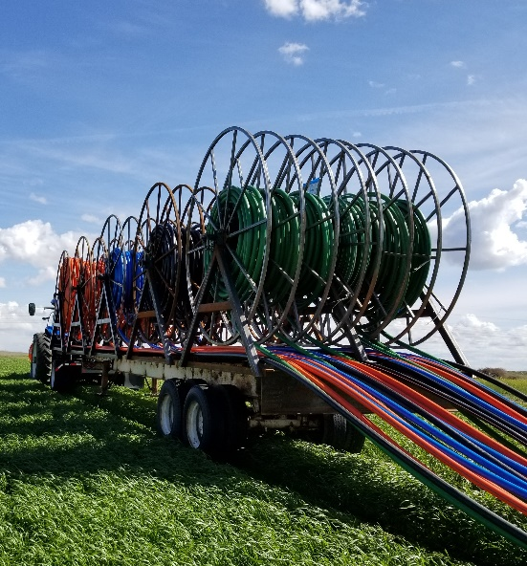
About PPI:
The Plastics Pipe Institute, Inc. (PPI) is the major North American trade association representing the plastic pipe industry and is dedicated to promoting plastic as the materials of choice for pipe and conduit applications. PPI is the premier technical, engineering and industry knowledge resource publishing data for use in the development and design of plastic pipe and conduit systems. Additionally, PPI collaborates with industry organizations that set standards for manufacturing practices and installation methods.

